

TOM Integration

Interface Specification

STORELINE

To

GFO

[D019 to D033]

Project BEN Code: | W60416
Author: | Debasis Pattanaik
Date: | 05/02/2007
Version: | 0.1
Status: | Draft
Modified By:
Reviewed By: | Ganesan, Sankar

Change Record

Author | Date | Version | Change Reference, description
Debasis Pattanaik | 05/02/2007 | 0.1D | Draft
Ganesan, Sankar

Reviewers

Name | Date | Version | Position
Ganesan, Sankar |  |  | Draft

At least one reviewer is required.

Sign-Off

By signing this form, I understand and agree with the contents of this document.

Business Owner/Customer | Erwin Oguz
Position | Solution Architect
Signature
Date

Distribution List

Name | Date of Issue | Version
Oguz Erwin
David Onyett
Venkateswara Rao

Document Source

Related Documents: XML Store Line source file schema, GFO system TSD document & Store line system FSD document

Directory: <to give path>

File Name:
XML Store Line source file schema - tes.jp.retail.storeline.invadjust.v2.7
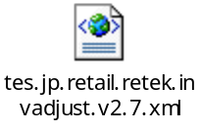
GFO system TSD document - TSD008 - Stock Record - non-sales events.doc
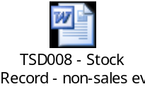
Store line system FSD document - FS1847_BO_Stock_Interfaces.doc
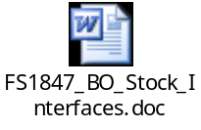

Information Architecture Context diagram
Will be provided

Mapping spreadsheet
Will be Provided
Table of Contents
1 Introduction 7
1.1 Purpose of Document 7
1.2 Background 7
1.3 Scope 7
2 Description and Requirements for the End-to-End Interface 8
2.1 Description of the End-to-End Interface 8
2.2 Architecture 8
2.3 Requirements for the End-to-End Interface 9
3 Processing required in an Extract-Stage of the interface 10
3.1 Scope 10
3.2 Source Message Schema 10
3.3 Message Format 11
3.4 Message Transport Details 12
3.5 Naming and Configuration 12
3.6 Environment and Security Context 12
3.7 Non-Functional Requirements 13
4 Processing required in the Messaging Stage of the interface 14
4.1 Scope 14
4.2 Data Validation 14
4.3 Filtering 14
4.4 Mapping 14
4.5 Stored Procedures 14
4.6 JIP00 – Package Set switch – new subroutine 14
4.7 JIP11 – process wastage – new subroutine 14
4.8 JIP12 – process stock counts – new subroutine 15
4.9 JIP13 – process stock takes – new subroutine 15
JIP14 – process miscellaneous stock movements – new subroutine 15
4.10 Message Format 16
4.7 Message Transport Details 16
4.11 Naming and Configuration 17
4.12 Environment and Security Context 17
4.13 Non-Functional Requirements 17
5 Processing required in the <third stage of the interface> 18
5.1 Scope 18
5.2 Data Validation 18
5.3 Filtering 18
5.4 Mapping 18
5.5 Target Message Schema 18
5.6 Message Transport Details 18
5.7 Naming and Configuration 18
5.8 Environment and Security Context 18
5.9 Non-Functional Requirements 18
6 Testing Deliverables 19
7 Deployment 20
8 Assumptions and Outstanding Issues 21
8.1 Assumptions 21
8.2 Outstanding Issues 21
Appendix A Volumes 22
• Glossary 23
Appendix B Document Control 24

Introduction

Purpose of Document
The purpose of this document is to describe the interfacing requirements w.r.t. STORELINE inventory adjustment data e.g. Wastage (out-of-code and damaged), Stock counts, Stock takes & other movements into GFO.

The document is of a sufficiently technical in nature to allow a developer to build an actual interface. Additionally the document contains detail that might sit logically within a Technical System Design (TSD) document, but is contained here for expediency. Therefore the GFO system Technical System Document (TSD) and store line system Functional System Document are provided for better understanding of this interface.

This interface is only for US implementations. Turkey implementation does not require this interface.

Background
As part of Tesco Operating Model program, there is requirement to bridge the functionalities of enterprise applications including STORE LINE and GFO. To achieve this functionality, high level process flow architecture has been designed and approved by Tesco’s Enterprise Architecture team. As part of this process flow architecture there is a set of interfaces that has been identified to be developed to transfer Inventory Adjustment data from STORE LINE into GFO.

Scope
The Interface Specification covers:

- audit requirements across the interface
- security requirements across the interface
- timing/frequency requirements or constraints
- support requirements
- archiving
- the data format to be used for the interface at each stage (e.g. xml messages)
- the normal processing required at each stage
- recovery from failure required at each stage
- volumes.

Note that it is Tesco strategy to avoid placing any business logic in integration layer processing.

Description and Requirements for the End-to-End Interface

Description of the End-to-End Interface
The interface is to upload the Inventory Adjustment data (Wastage, Stock counts, Stock takes & other movements) from STORE LINE into GFO. The Upload is a full upload in nature.

The interface will be governed by BizTalk Orchestration, which expects the Inventory Adjustment data (| delimited flat file) from STORE LINE interface. The store line interface will put this file (*.dat) in the shared location through RTI SOAP adapter. The BizTalk server then transfers this flat file data by invoking GFO stored procedures through DB2 adopter. BizTalk will first invokes JIP00 – package set switch- stored procedure to get the stream information which is passed along with other input attributes (wastage/count date & time, Reason Code, Store No, Adjusted Quantity etc) to get updated/inserted in GFO underlying table. The output attributes returned by stored procedure will determine the success/failure of this updating.

The interface will make use of the audit and traceability components that are being developed as part of the Operational Framework stream. Developers should put a ‘placeholder’ in their code / configurations as appropriate.

Architecture
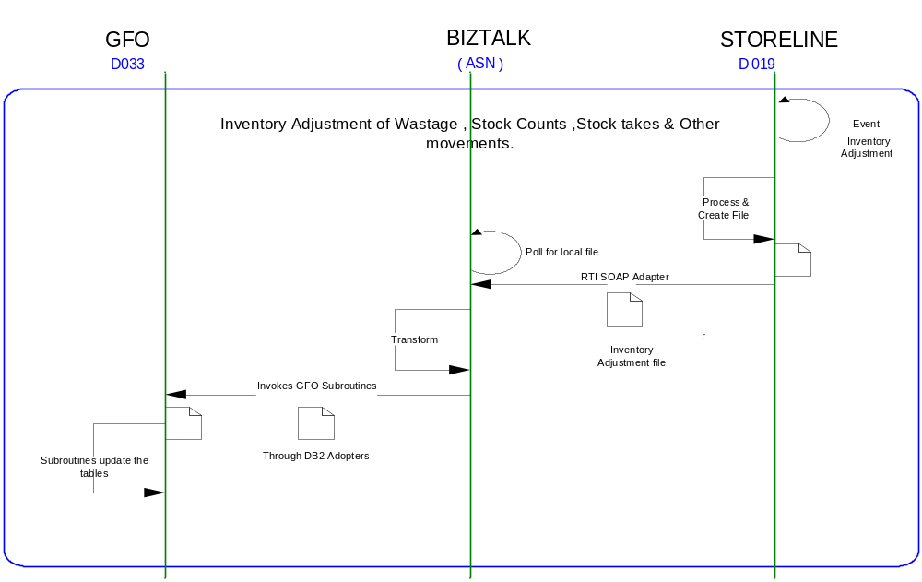

Requirements for the End-to-End Interface

Audit Requirements | The interface will use the components provided by the Operational Framework to satisfy audit requirements.
Security Requirements | The interface executes within a secure private domain. There are no additional security considerations required.
Timing/Cut-off Constraints | To be finalised.
Performance Requirements | The interface should be capable of extracting data in the form of flat file from the shared location at TIMS side and delivering the resulting to another shared location at ORMS side before the identified cut-off time. The interface should run on real time basis.
Reliability and Availability Requirements | The interface-run should be atomic in nature. Where it is not possible to implement an atomic nature of interface, appropriate mechanisms should be in place to raise/alert appropriate parties.
Scalability Requirements | N/A - No scalability issues exist.
Operational Support Requirements | No such requirement has been agreed upon at the time of writing this document. However, it is perceived that there would be interface support requirements after go-live date that would require an evaluation.
Likelihood of Change Requirements | There is no such requirement
Cultural/Global Consideration Requirements | N/A
Legal Requirements | N/A
Compliance To Standards Requirements | No compliance exceptions.

Processing required in an Extract-Stage of the interface

Scope
STORELINE creates a pipe | delimited flat file on real time basis whenever it receives an inventory adjustment (D019) data. BizTalk in turn picks up the file from the shared location and invokes series of subroutines through DB2 Adopter to update/insert the underline table of GFO.

Source Message Schema
Field Name | Optional | Type | Description
HEADER RECORDS
CapturedBy – CreatedBy |  | String
DateOfExtract | Yes | String | Store-line extraction date
DelAfterDate |  | String | Delivery before date
DelBeforeDate |  | String | Delivery after date
Description |  | String | Free form description
DriversName-Courier |  | String | Courier Driver Name
ExpectedDelDate |  | String | Expected Delivery Date
InvoiceNumber |  | String | Invoice Number
InvoiceTaxTotal |  | String | Invoice Tax Total
InvoiceTotal |  | String | Invoice Total
NoOfDetailLines | Yes | Unsigned Int | No. of Detail Items
OrderDate |  | String | Count Order Date
OrderNumber-TransactionNo | Yes | Unsigned Int | Count Order Number
OrderType-CountType |  | Unsigned Int | Count Order Type
OriginalOrderNumber |  | Unsigned Int | Original Order Number
ReasonCode |  | number | Reason Code
RecordType | Yes | String | Record Type
RefNo1 |  | String | Reference No 1
RefNo2 |  | String | Reference No 2
Remarks |  | String | Remarks
ReprocessedFlag |  | number | Re-Processed Flag
StoreAddress |  | String | Location Address
StoreName |  | String | Location Name
StoreNo | Yes | Unsigned Int | Location of extracted data
SupplierAddress |  | String | Supplier Address
SupplierCode-ToStore |  | String | Supplier Code
SupplierName |  | String | Supplier Name
SupplierType |  | Unsigned Int | Supplier Type
TimeOfExtract | Yes | String | Extraction time of data
TotalQty |  | String | Total Quantity
TotalValue |  | String | Total Value
TransactionDateTime |  | String | Transaction Date and Time
UserName |  | String | Operator name
DETAIL RECORDS
DateOfExtract | Yes | String | Storeline extract date
InvoiceCost-Excl-PerUOM |  | String | Invoice cost excluding (Per UOM)
InvoiceQty |  | String | Invoice Quantity
ItemDescription |  | String | Item Description
ItemNumber |  | Unsigned Int | Item CodeItem Code  Used to populate ITEM field
LineNumber |  | Unsigned Int | Transaction line number
Location |  | String | Location in store
OrderNumber-TransactionNumber |  | Unsigned Int | Concatenated with store no to get Batch Number.
OrderQuantity-SentQuantity |  | Unsigned Int
OrderType |  | Unsigned Int
PackSize-Ratio |  | Unsigned Int
ReasonCode |  | Number | Reason Code field direct mapping
RecordType |  | String | Type of record as per Storeline
ReferenceNo |  | Unsigned Int
SellingPricePerUOM |  | String
Sign |  | String | Sign indicator  - negative  + positive  Used to get Adjusted Qty
StoreNo | Yes | Unsigned Int | Concatenated with Order Number-Transaction Number to get Batch Number.
SupplierItemNo-CatalogueNo |  | String
TaxPercentageOnCost |  | String
TimeOfExtract | Yes | String
TransactionQty |  | String | Transaction Quantity concatenated with sign indicator will give meaningful value.
TrsCostPrice-Excl-PerUOM |  | String
UOMCode |  | Unsigned Int
UOMDescription |  | String

Message Format
The source message is in the form of pipe | delimited flat file from STORELINE.

Message Transport Details

Feature | Specification | Additional Information
Source System Name | STORELINE
Source Platform / OS | IBM AIX
Source Physical Location
Source Underlying Data Storage Technology | SQL Server
Target System Name | Biztalk 2006
Target Platform / OS | Biztalk 2006 Server
Target Physical Location
Target Underlying Data Storage Technology | File Share
Transfer Function | HTTP (Put/Post) □  HTTPS (Put/Post) □  Message Queue □  FTP ☑  File Drop(Windows) ☑  (XCOM) □
Data Format. | XML □  Delimited ☑  Positional □ | | delimited
Decryption/Encryption | No
Decompression/Compression | No
Transmission Mode | Synchronous □  Asynchronous ☑  Bulk Data □
Real-time/Scheduled Batch | Not yet decided
Archiving | There is no requirement to archive the messages.
Logging | Logging should occur, such that the message can be recreated if necessary.
Error Handling | Not yet decided  Processing should prevent sending of duplicate messages, unless this occurs during recovery from failure.

Naming and Configuration

Biztalk – 2006
Package Name: Tesco_ TOM_Integration_INVENTORY_ADJ_from_STORELINE_to_ORMS
BizTalk Procedure
Name | Tesco_TOM_Integration_INV_ADJ_GFO
<Placeholder for other package components/steps>
<Placeholder for other package components/steps>

Environment and Security Context
Account details will be included here once we have visibility of the environments.

Non-Functional Requirements
Not Applicable

Processing required in the Messaging Stage of the interface

Scope
The BizTalk server transfers the source message schema file to GFO by invoking a series of stored procedures within DB2.This will first invokes JIP00 – package set switch- stored procedure to get the stream information which is passed along with other input attributes (wastage/count date & time, Reason Code, Store No, Adjusted Quantity etc) to get updated/inserted in GFO underlying table.

Data Validation
Data Validation will be done by the target ORMS system.

Filtering
There is no filtering requirement.

Mapping
Mapping document will be provided subsequently.

Stored Procedures
The stock event data from Store Line then immediately use it to invoke the relevant stored procedure(s) within DB2. The types of stock event involved are:

- Wastage (out-of-code and damaged)
- Stock counts
- Stock takes
- Other movements to / from other locations e.g. supplier, DC

The following description gives the details of stored procedure need to be invoked to pass data from STORE LINE to GFO.

JIP00 – Package Set switch – new subroutine
JIP00 will determine a store’s database stream then point subsequent processing to that package set.

JIP11 – process wastage – new subroutine
JIP11 will take wastage data and use it to update the following tables:

TXJJ0PDM stock movements
TXJJ0PPH product profile history
TXJJ0BKS stock record (via module JJ004D)

Retalix (StoreLine) record type 327, reason code 515 (discontinued) = out-of-code
Retalix (StoreLine) record type 327, reason code 516 (end of season) = out-of-code
Retalix (StoreLine) record type 327, reason code 517 = damaged
Retalix (StoreLine) record type 327, reason code 518 = out-of-code
Retalix (StoreLine) record type 327, reason code 519 (insufficient code) = out-of-code

The full specification is a separate document in the PROGRAM SPECS sub-folder.

JIP12 – process stock counts – new subroutine
JIP12 will take stock count adjustment data and use it to update the following tables:

TXJJ0ASC applied stock count
TXJJ0PPH product profile history
TXJJ0BKS stock record (via module JJ004D)

Retalix (StoreLine) record type 315 = stock count (difference)

The full specification is a separate document in the PROGRAM SPECS sub-folder.

JIP13 – process stock takes – new subroutine
JIP13 will take stock take data and use it to update the following tables:

TXJJ0ASC applied stock count
TXJJ0PPH product profile history
TXJJ0BKS stock record (via module JJ003D)

Retalix (StoreLine) record type 314 = stock count (absolute)

The full specification is a separate document in the PROGRAM SPECS sub-folder.

JIP14 – process miscellaneous stock movements – new subroutine
JIP14 will take miscellaneous stock record adjustment data and use it to update the following tables:

TXJJ0PDM stock movements
TXJJ0PPH product profile history
TXJJ0BKS stock record (via module JJ004D)

Retalix (StoreLine) record type 322 = store-to-store transfer in
Retalix (StoreLine) record type 323 = stock adjustment (+ve or -ve)
Retalix (StoreLine) record type 325 = return to supplier
Retalix (StoreLine) record type 326 = return to DC
Retalix (StoreLine) record type 350 = store-to-store transfer out

The full specification is a separate document in the PROGRAM SPECS sub-folder.

Message Format

4.7 Message Transport Details
For messages destined for ORMS system, the following applies.

Feature | Specification | Additional Information
Source System Name | Biztalk 2006
Source Platform / OS | Biztalk 2006 Server
Source Physical Location
Source Underlying Data Storage Technology | File System
Target System Name | GFO
Target Platform / OS | COBOL/UNIX
Target Physical Location
Target Underlying Data Storage Technology | RDBMS
Transfer Function | HTTP (Put/Post □  HTTPS (Put/Post) □  Message Queue □  FTP □  File Drop (Windows) □  (XCOM) □  RTI File Adapter □  DB2 File Adapter ☑
Data Format | XML □  Delimited □  Positional □  COBOL format ☑
Decryption/Encryption | No
Decompression/Compression | No
Transmission Mode | Synchronous □  Asynchronous ☑  Bulk Data □
Real-time/Scheduled Batch | Real-time
Archiving | There is no archiving requirement
Logging  Should logs be kept of all actions? For how long should these be stored? | Logging should occur, such that the message can be recreated if necessary.
Error Handling | Not yet decided  Processing should prevent sending of duplicate messages, unless this occurs during recovery from failure.

Naming and Configuration

Biztalk 2006
Instruction Name:
Instruction Details
Description | To be determined
Enabled | True
Type
Operational Window
Schedule | N/A
Enabled | False
Host Details
Account | To be determined
Operational Details
Worker Threads
Priority
Batch Size
Period
Retry Attempts
Timeout
Require Data Send
Exception Management
Treat Fatal Adapter Exception As
Treat Unhandled Exceptions As

Environment and Security Context
Account details will be included here once we have visibility of the environments.

Non-Functional Requirements
On successful delivery of the file to the target system, the audit log should be updated via the Operational Framework pipeline component or adapter (to be determined).

In the event of a failure the file should be written to the failed files location, and an alert should be raised.

Processing required in the <third stage of the interface>

Scope
There is no intermediate staging is required for this interface. So this section is not applicable.

Data Validation
Not Required

Filtering
Not Required

Mapping
Not Required

Target Message Schema
Not Required

Message Transport Details
Not Required

Naming and Configuration
Not Required

Environment and Security Context
Not Required

Non-Functional Requirements

Not Required

Testing Deliverables
Unit Test Scripts and test cases are kept at the following location <location>

Deployment

Assumptions and Outstanding Issues

Assumptions
ID | Assumption
1 | Rollback transaction supported by GFO in case of failure.

Outstanding Issues
ID | Issue | To be addressed by
1 | Stored procedure JIP00 – package set switch (used to get STREAM information) foot-prints need to be defined | Erwin Oguz
2 | DB2 adopter specification to call sub procedures need to be defined | Erwin Oguz
3 | Error handling with respect to DB2 copybook need to be defined | Erwin Oguz
4 | Return output parameter of stored procedure need to be defined with details of its reason code & maintaining error log. | Erwin Oguz
5 | Store Line source file Physical Location need to be defined | Erwin Oguz

- Volumes
- Glossary

Acronym | Term | Description
EAI | Enterprise Application Integration | The process of meeting the data requirements of applications by providing a message based transport from disparate data sources across all forms of enterprise technology.
EAI Layer | Enterprise Application Integration Layer | Refers to the integration services provided to implement EAI. In contrast to the EIA Layer for data services. See below.
EIA | Enterprise Information Architecture | Creation of a strategic single view of data across the enterprise.
Interface | Interface | Many definitions exist for 'interface'. In general, 'interface' refers to the link between a data source and a data target. And there are properties of the interface in this context. However more specifically 'interface' refers to one end of a data link, hence the terms source interface and target interface, and both the source interface and the target interface will have specific properties of their own.
GFO | Group Forecasting and Ordering | The GFO operates on Tesco deals with the forecasting & Ordering.
Storeline | STORE used for inventory purposes. | The store line operates on Tesco deals with the inventory control.
XSD | XML Schema Definition | It describe the elements in an Extensible Markup Language (XML) document
XML | Extensible Markup Language | An open standard for describing data. It is used for defining a common method for identifying data. It supports business-to-business transactions and also uses electronic data interchange and Web services.
FTP | File Transfer Protocol | The Internet File Transfer Protocol (FTP) is defined facilities for transferring files to and from remote computer systems.

- Document Control
Change Record

Author | Date | Version | Change Reference, description
Debasis Pattanaik | 05/02/2007 | 0.1D | Draft
Ganesan, Sankar

Related Documents

Author | Date | Version | Title
To be filled

Distribution

Name | Position | Approver/Contributor/Other
Erwin Oguz | Enterprise Architect

